FlyDreamAir is a major airline which covers both international and domestic routes with a large fleet of aircrafts. The airline has a large network of travel agencies and customers across the world. FlyDream is planning to digitalize its business processes and operations, and has identified three potential projects:

• Project 1: develop an IT software system to manage customers and allow them to book flights, manage flight reservations, seat selections, purchasing in-flight services such as food and drinks.

UML Classes:

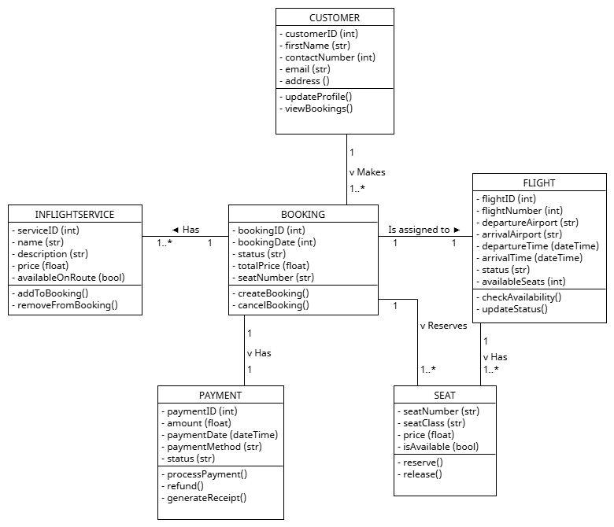

**Module utilisation:**

* Datetime: to work with time and time-zones
* Pickle: for object serialisation
  + Pickle is used over other formats (e.g. JSON library) as datatime objects cannot be saved in JSON format, however pickle can do this.
* CustomTKinter: for UI

**Program outline:**

On startup:

* Check if pickle files are in the program folder, for data storage
  + If files are missing, create them
  + If files are there, continue as normal

Basic functionality / features:

* Customer
  + Update Profile
  + View Bookings
* Flights
  + View flights
  + Book flights
  + Search flights
* In Flight Services
  + Add to Booking
  + Remove from Booking
* Booking
  + Create Booking
  + Cancel Booking
* Payment
  + Process Payment
  + Process Refund
  + Generate Receipt
* Seat
  + Reserve
  + Release